Times Series Analysis – Assignment

Name: Shubham Dhadage

PRN:22060641063

**Define**: The question is asking you to perform a time series analysis on a provided data set that contains information about Covid positive cases and deaths in India. The analysis should include smoothing techniques, an ACF and PACF study, and any necessary transformations of the data. The goal is to identify patterns and trends in the data and make predictions about future values.

**Analyse:** We plot time series data in this graph to see if there is any basic trend, as well as any seasonality, for the number of COVID cases and deaths in India.

We can say that there is an increasing trend in deaths and cases because, as we can see over time, there is exponential growth in the number of COVID cases.

We performed the following steps on Covid cases and death data:

1. Calculated Descriptive Statistics and plotted trend lines using Linear and Quadratic trend models.

2. Calculated the difference in both data series using the difference function and plotted time series plot for the difference series.

3. Calculated ACF and PACF functions on the difference series and stored the PACF residuals results.

4. Fit the ARIMA model on the difference series with various values of AR, Difference, and MA in the range between 0 to 2.

5. Plotted time series of the Residuals obtained from the best fitted ARIMA model and used ACF on the residuals series.

6. Plotted the normality plot of the Residuals to check whether they follow the Normal distribution or not.

**Tools:** time series plot , trend analysis plot , ACF and PACF plots and ARIMA model.

**Dataset:**

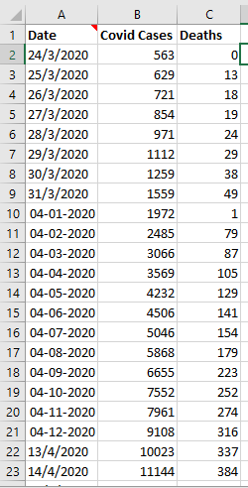

**TIME SERIES PLOT FOR COVID CASES**

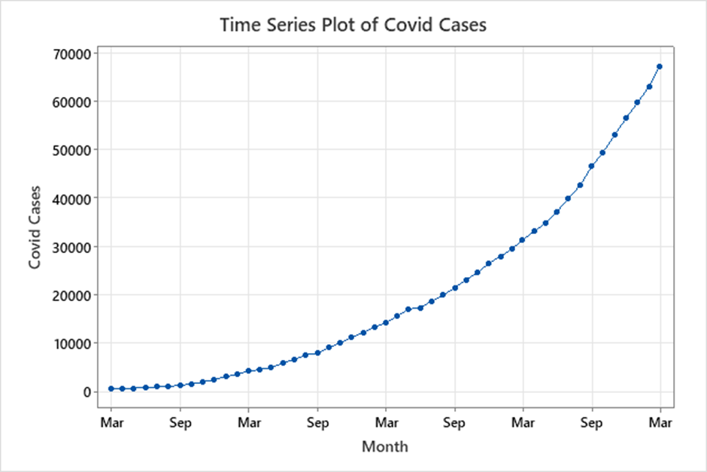

**Descriptive statistics :**

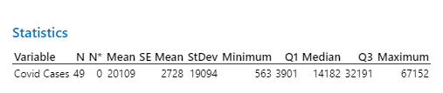

**Quadratic trend model**

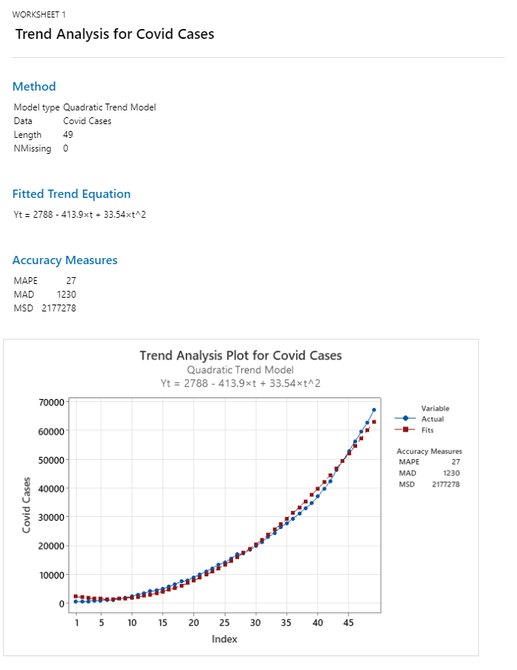

● Here

we plot the trend analysis plot with quadratic trend fitting on it as the MAPE here is 27 we do the log transformation in the values and plot again the MAPE then observed comes out to be 0.9921 which is relatively small.

**ACF**

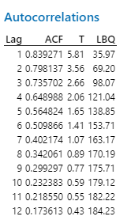

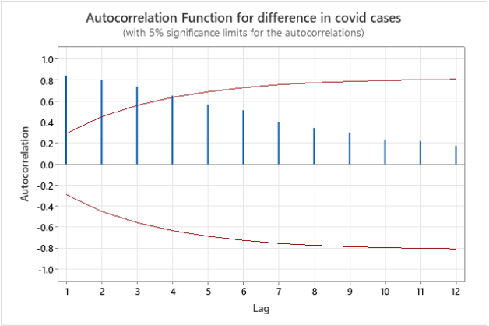

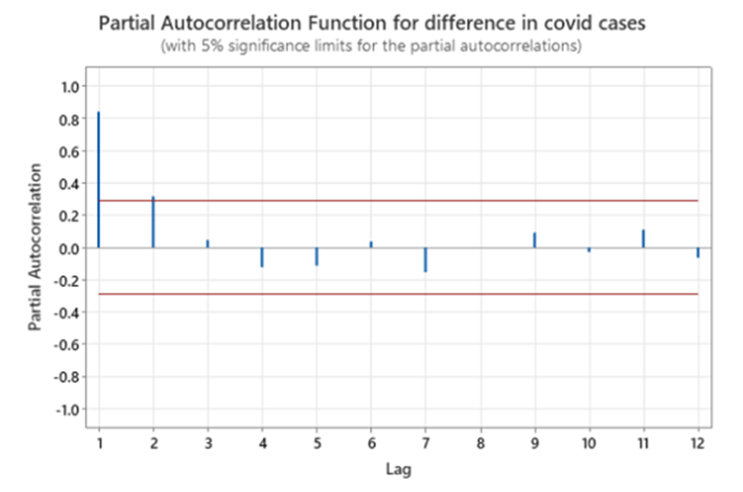

**ARIMA MODEL(1,1,1)**

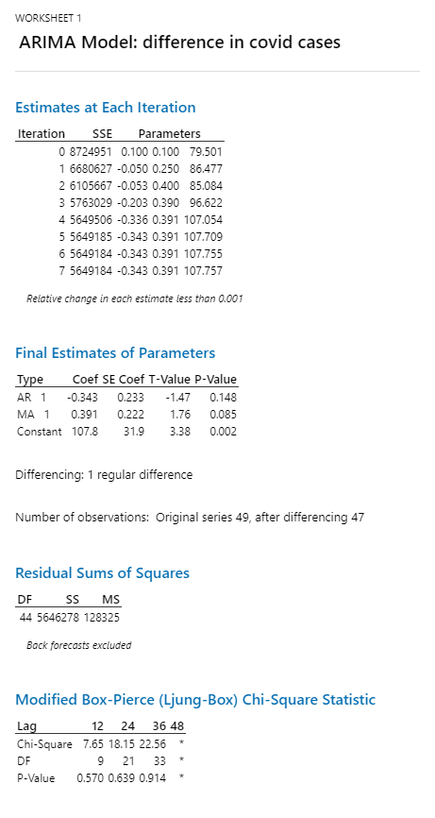

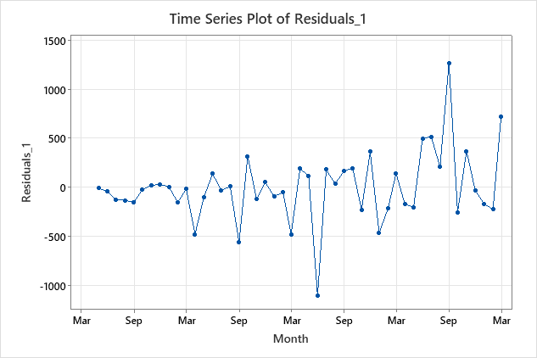

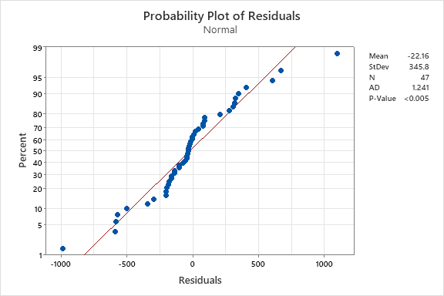

**ACF Of residuals**

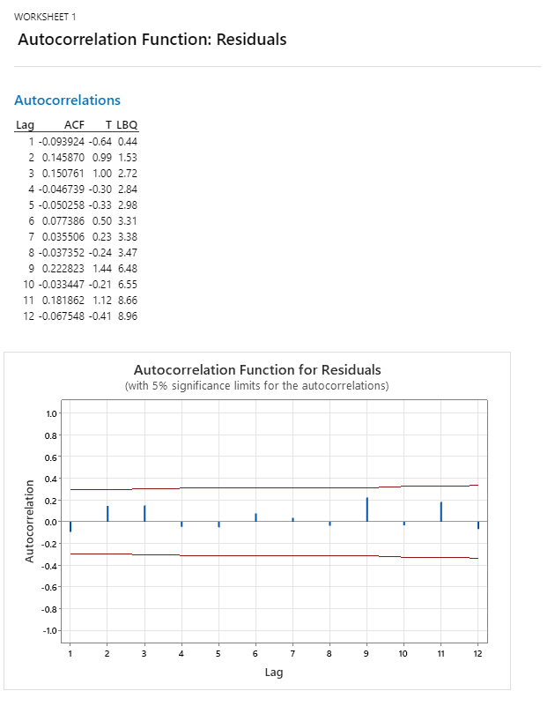

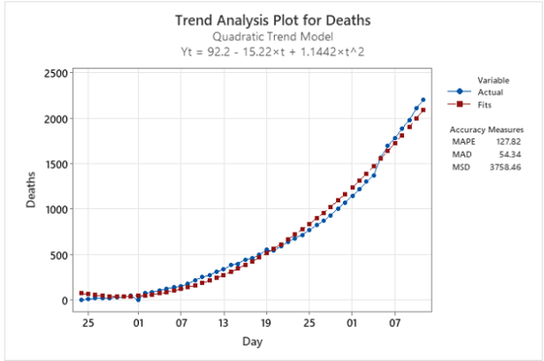

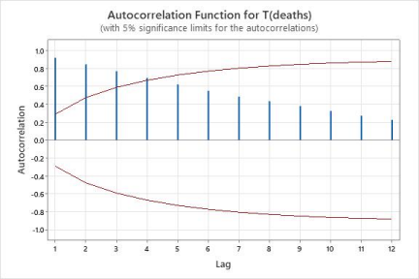

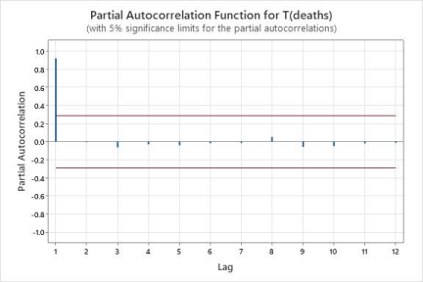

**Conclusion:**

To summarize, the analysis of Covid cases and death data involved calculating descriptive statistics, fitting trend models, calculating the difference in both data series, and using ACF and PACF functions to determine the best fitted ARIMA model. The quadratic trend model was found to be the most appropriate representation of trend analysis. The ACF and PACF plots indicated the presence of auto-correlation in the data, and these plots were used to select the best fitted ARIMA model. The ARIMA model is a suitable method for analyzing this type of time-series data, and the normality plot of the residuals was used to check whether they follow a normal distribution. Overall, the analysis provided valuable insights into the impact of Covid over time and the appropriate methods for analyzing this type of data.